|  |  |
| --- | --- |
| **Name** | Umar Hayyat |
| **Roll No** | 360 |

**Lab 8**

**Introduction to list and function**

**Objectives:**

* Use a list and find maximum and minimum number in it.
* Use a function to find median of an array.

**Task 1:**

Create a list with following 5 items

7, 9,’a’,’cat’,False

1. Append 3.14 and 7 to the list.
2. Insert the ‘dog’ at position 3.
3. Find the index of cat.
4. Count the number of 7’s in the list.
5. Remove the first 7 from the list.
6. Remove ‘dog’ from the list using pop and index.

**Code:**

L=[7, 9,'a','cat',False]

L.append(3.14)

L.append(7)

print("list will be",L)

L.insert(3,'dog')

print("list will be",L)

a=L.index('cat')

print("index of 'cat'is ",a)

b=L.count(7)

print("number of 7's is ",b)

L.remove(7)

print("list will be ",L)

L.pop(L.index('dog'))

print("Final list will be ",L)

**Output:**

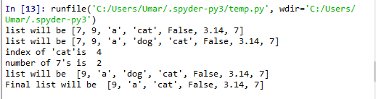

Figure 8.1: Output of Task 1

**Task 2:**

Initialize list with mid term scores of 5 student. Find the maxium and minimum scores. Find the sum and average of class using for loop. Notify if any student have 30 marks.

**Code:**

List=[0,5,10,15,20]

a=max(List)

print("maximum scores are ",a)

b=min(List)

print("minimum scores are ",b)

sum=0

for m in List:

sum=sum+m

print("sum of marks is ",sum)

averg=sum/len(List)

print("average of marks is ",averg)

s=30 in List

print(s)

**Output:**

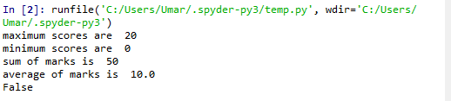

Figure 8.2: Output of Task.2

**Task 3:**

Write a function which return the median of an array.

**Code:**

def median(L):

P.sort( )

if(len(P)%2==0):

b=len(P)//2-1

c=len(P)//2

x=(L[b]+L[c])/2

return(x)

else:

y=len(P)//2

return(P[y])

P=[3,4,8,7,11]

z=median(P)

print("median of an array is ",z)

**Output:**



Figure 8.3: Output of Task.3

**Conclusion:**

I learnt how to use a list and find median in it. I also learnt how to find maximum and minimum number in list and take the sum and average of the numbers in the list.